WANTED FUGITIVE
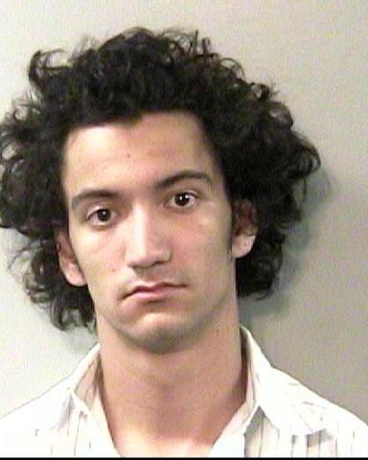
Christopher Ponce.
If you have seen this fugitive please contact the
U S Marshals Service
1-800-336-0102
(813) 415-1967
Or text 847411 use keyword USMFL
Rewards Offered for his capture.

